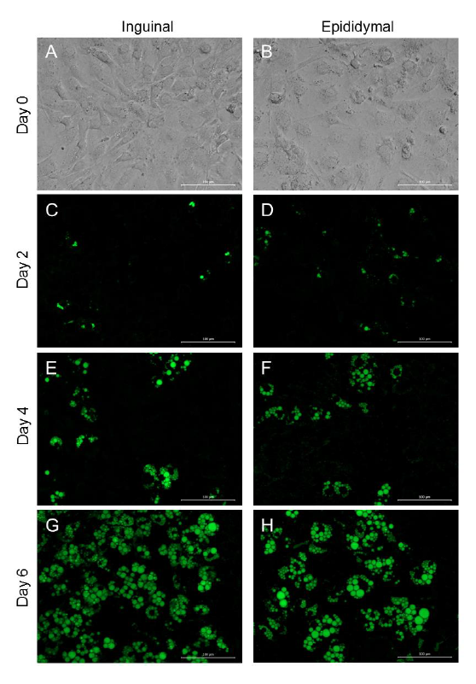
Staining of intracellular triglycerides in fat depot-specific immortalized murine cell lines in course of differentiation using AdipoRed™ reagent. A, C, E, and G show images of inguinal and B, D, F, and H epididymal cells. Bright field pictures were taken of undifferentiated cells (A and B, 20 X magnification) and fluorescence microscopy images of differentiating cells (C-H, 20 X magnification, FITC channel; exposure time of 1000 ms). Shown are representative pictures from two independent experiments. White ruler in right corner shows 100 μm.

